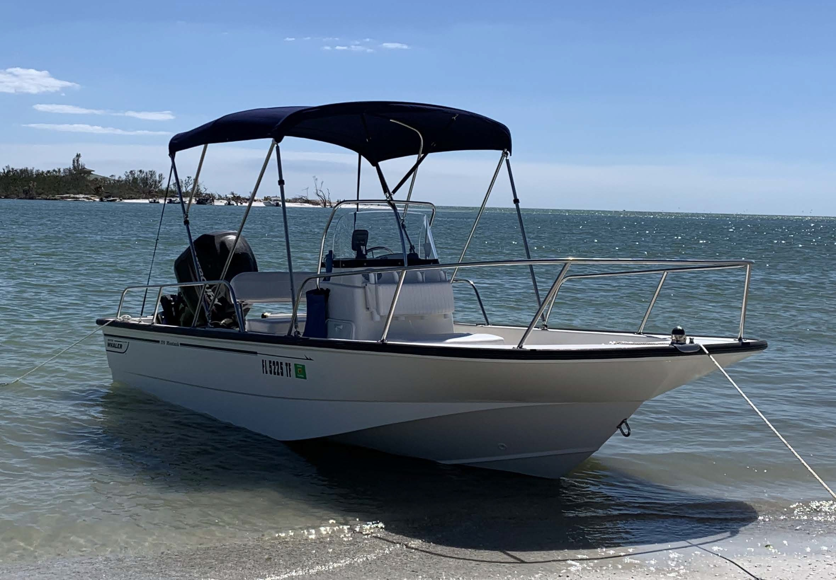Owner’s Information
Name: Kenneth Ryan
Phone Number: 703-906-7629

Email Address:
kar5671@gmail.com

Boat Information

Make: Model:
Boston Whaler Montauk

Year: 2014

Make/Model of Engines:
90 HP Mercury

Hours on Engine:

Description of Boat:
17ft Center Console

Description of Electronics and VHF:
Garmin Depth Sounder/Fish Finder

Options Added on Boat:

Additional Comments:
New Battery Installed January. 2022 Includes Bimini, cushions, and cover

Price:

$29,000

